Prompt Used
Create a single-page responsive website called “Stellar Visions”, a virtual astronomy art gallery, using only HTML and CSS (no Bootstrap or frameworks).
Use a dark cosmic theme, a sticky navbar (Gallery, About, Feedback on the left; Sign Up on the right), an image gallery with hover zoom and glow effects, an About section, Feedback and Sign Up card-style forms with rounded inputs and hover effects, and a simple footer with a space-themed line.
Include smooth hover transitions, flexbox layout, mobile responsiveness, and provide the full HTML with embedded CSS.

Analysis and Comparison
The AI-generated version focuses heavily on visual design, including animations, gradients, and advanced styling. While this makes the website look attractive and professional, it also results in longer and more complex code that is harder to read and maintain.
In comparison, my version uses a simpler design approach with fewer effects and cleaner structure. This made the code easier to understand, edit, and debug. Through this comparison, I learned that while AI can quickly create visually rich designs, simplifying the output is important for learning, maintainability, and meeting academic requirements.

Git Link: https://github.com/mina-hill/WebPTask1

My Version
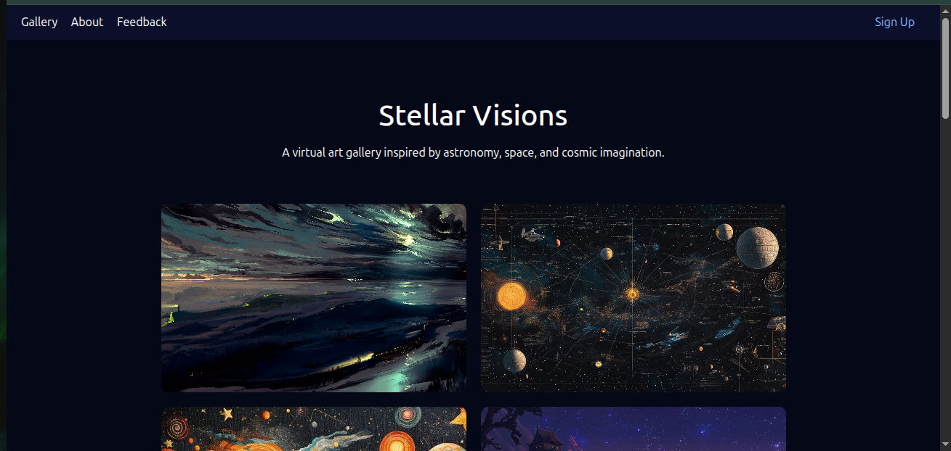

AI Version
